**Mobile Testing (Data Syncing with Website)**

Below i am dividing the document into different sections according to different headings

**Save Button**

The application Itself closes and shuts down itself after pressing save button sometimes and crashes then i have to restart and choose a different program again which is quite frustrating

It closed around 5 times in 20 presses

**Tool Button**

I have marked below the tools section, sometimes while making changes when only a pen is displaying, the pen vanished and only a cross is displayed and the application hangs for some time which is frustrating

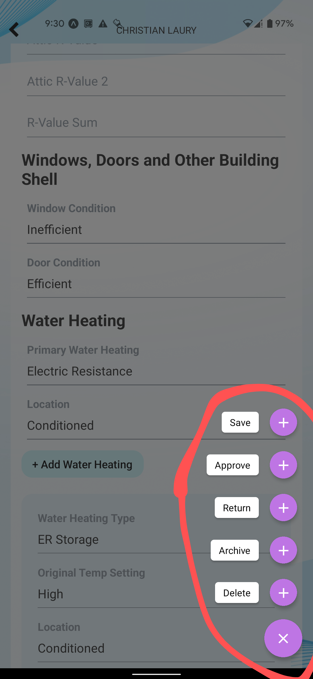

**General Section**

* Program is not set to read only! It can be changed but when save button is pressed after changing it it doesn't changes anywhere nor in the mobile app nor in the web app
* Changed Audit date in the mobile app then pressed save and the date was saved for the mobile app and also changed for the webapp
* Changed Weatherization date in the mobile app then pressed save and the date was saved for the mobile app and also changed for the webapp
* No option to remove audit/Weatherization dates in case entered date by mistake and no date was there?
* Changes in the comment section don't appear in the website whether i add or remove anything

**Audit (Section 1-11)**

Audit section is divided into different sections

1. **Home**

* Missing Section in the Mobile application in the audit section under Home Information section **(Conditioned Sq Ft. )**

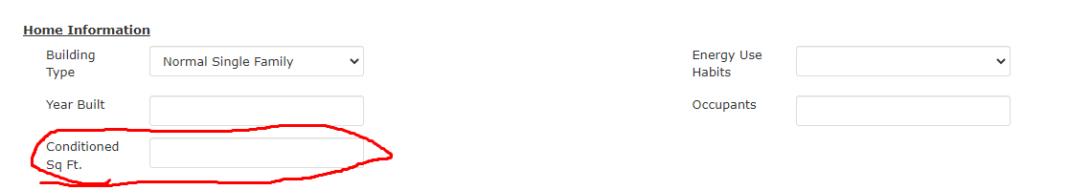

1. **Space Cooling**

Works Fine

1. **Space Heating**

Works Fine

1. **Other HVAC**

Works Fine

1. **Attic Insulation**

Works Fine

1. **Windows, Doors and other Building Shell**

Works Fine

1. **Water Heating**

Works Fine

1. **Appliances**

* No Heading is there for appliances in the mobile application whereas in the web app there is a separate heading for the Appliances
* I cant delete the already 2 added appliances in the mobile application
* Addition of line works fine

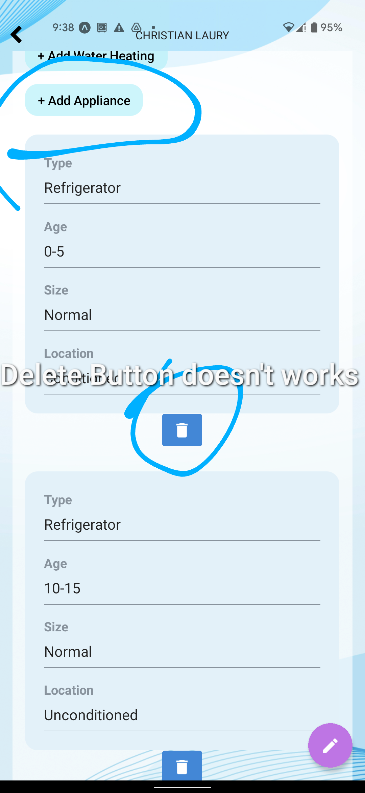

1. **Lighting**

* No.Of Bulbs Appear for 1 sec when i refresh the web page then disappears
* No. of Can Lights field is not available in the mobile application
* Delete Option Does Not Delete the line which i added

1. **Diagnostics Section**

No Diagnostics Section in the Mobile app?

Section in the below screenshot is not available in the mobile application

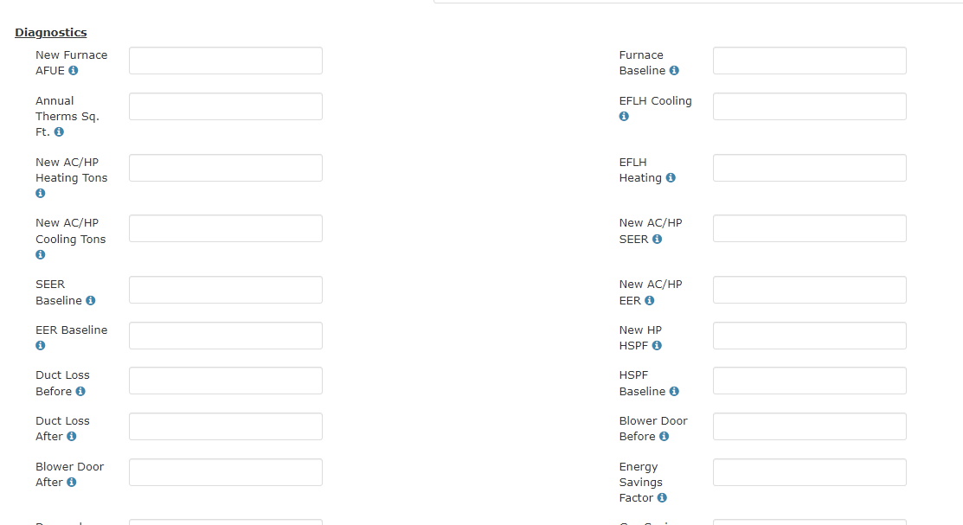

1. **Documents Section**

No Document Section appear under the audit column in the mobile app

**Document Section Separate**

Cannot delete documents from mobile app when i press delete button but i am able to upload them and they do appear in the web application

**Auditor Improvements**

Cannot delete line after adding one from the mobile application, the line does appear in the web app

**Weatherization Improvements**

Cannot delete line after adding one from the mobile application, the line does appear in the web app

**Auditor Recommendations**

Works Fine